/*Ashok IPBC MOR.Project R1SP3 Story5 Lab 7.28.19*/

Homework:

4. Complete R1:SP3: Story 5 – Load the Data into the ODS Database. Explain the entire process with explanations &amp; screenshots.

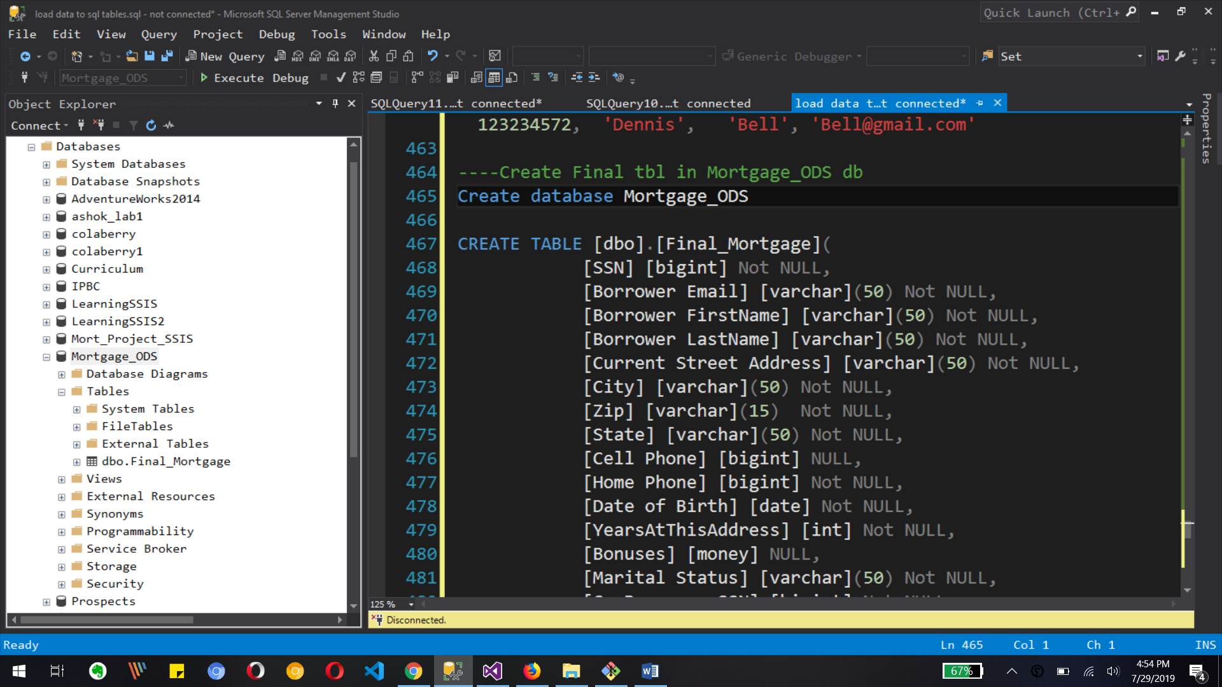

This image shows the configuration for new database mortgage_ODS also it's shows the creation of final_mortgage table which has all columns from source tables or staging tables

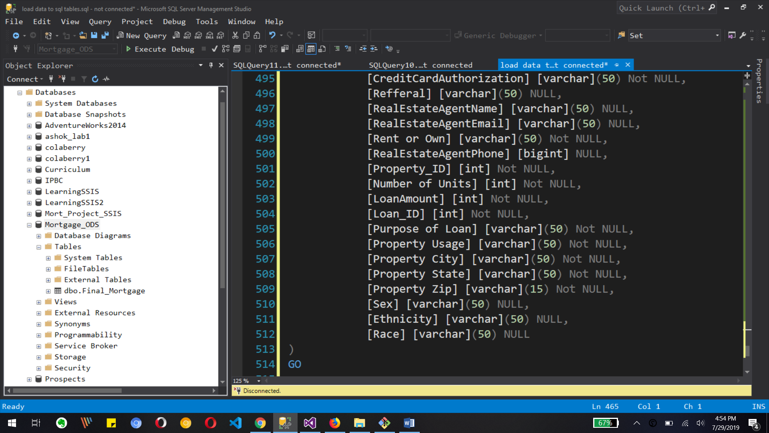

 above image shows different columns with its data type four mortgage project ODS database table

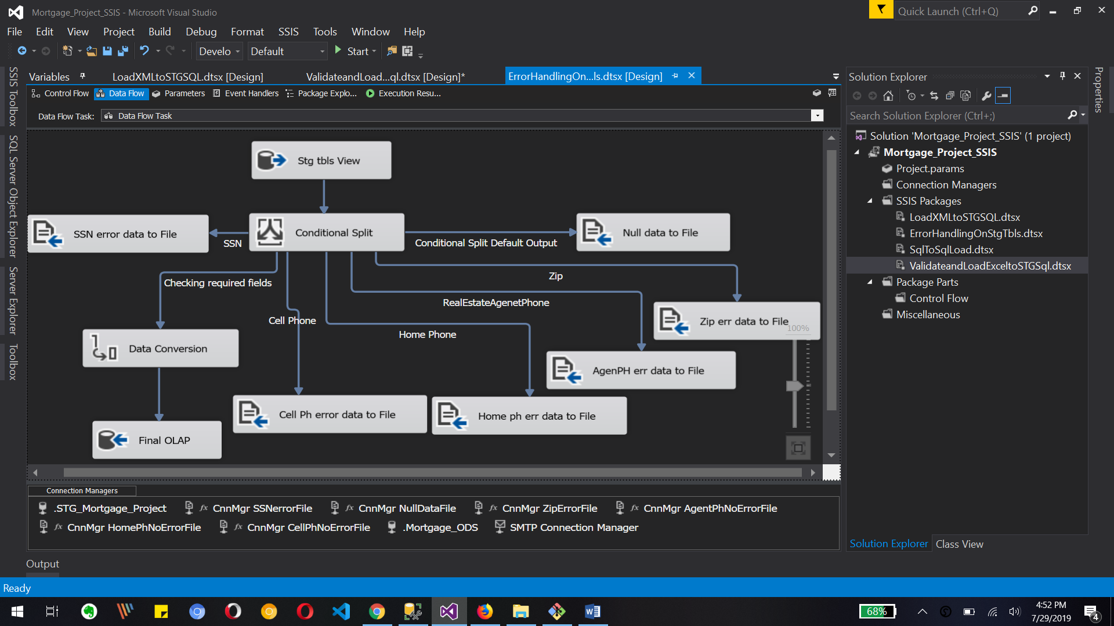

Now we are in ssis for creating our package to load our ODS table here rehab Source table unconditional split and other file destinations and also ODS destination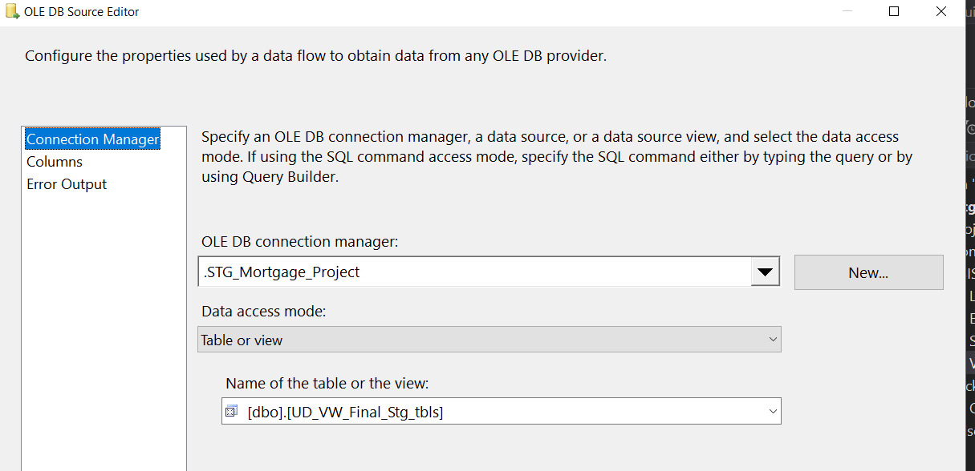

This is Connection Manager for oledb source with its final stg View

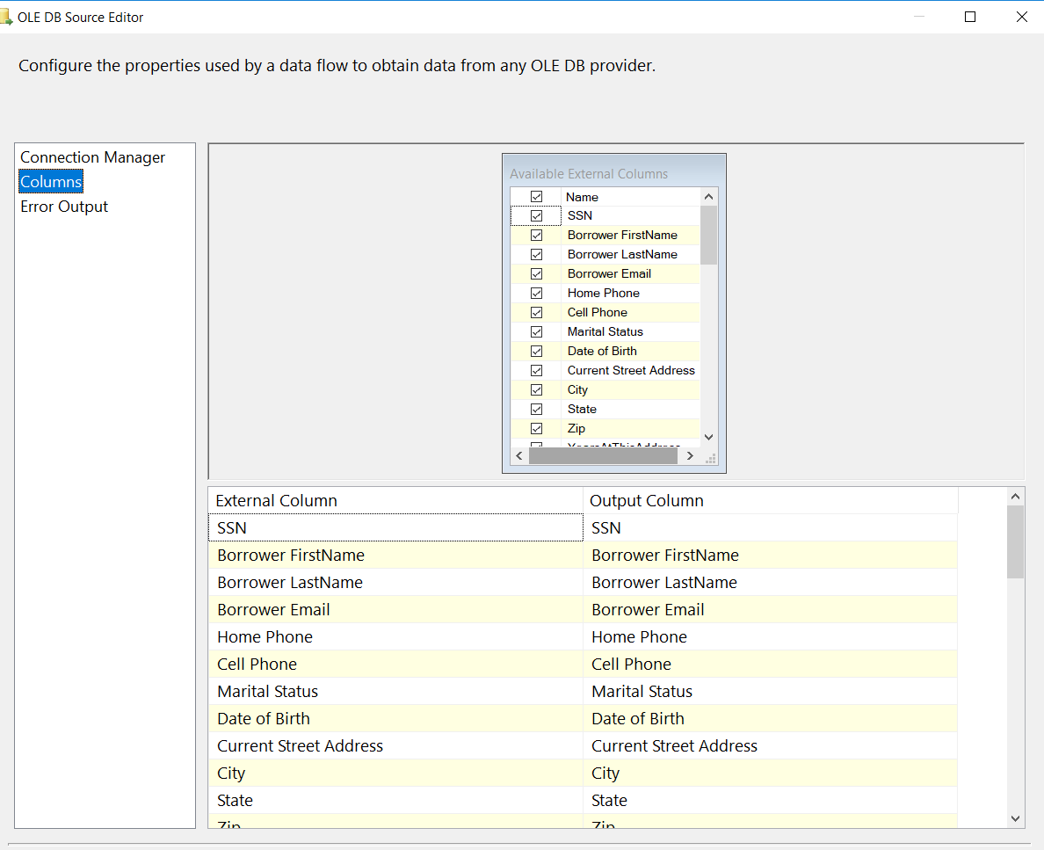

we need to select columns for our oledb source table so we have selected all input columns

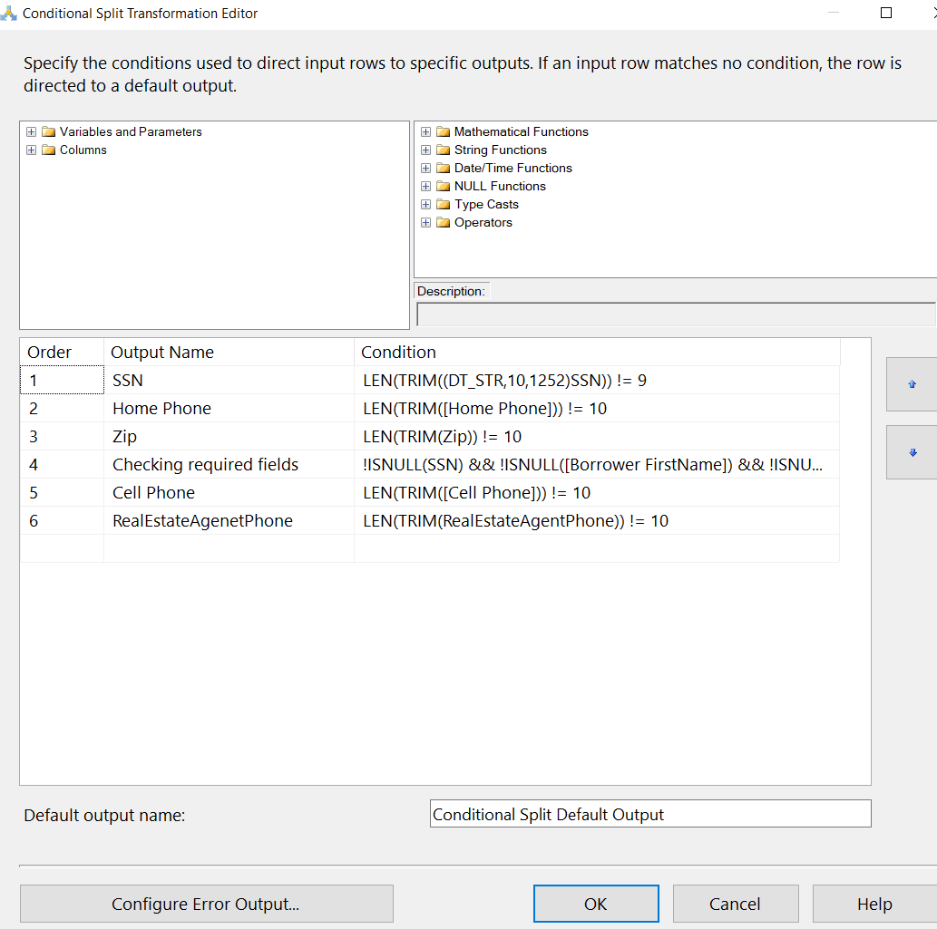This is conditional split transformation editor where do have different types of outputs

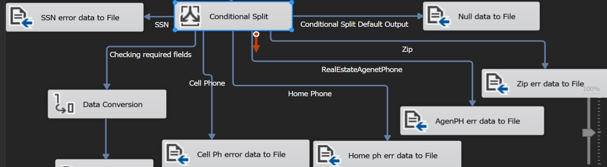

This image shows different output connected to file destination as example SSN error data file, cell phone number files etc, so we can store all rows with error in relevant files.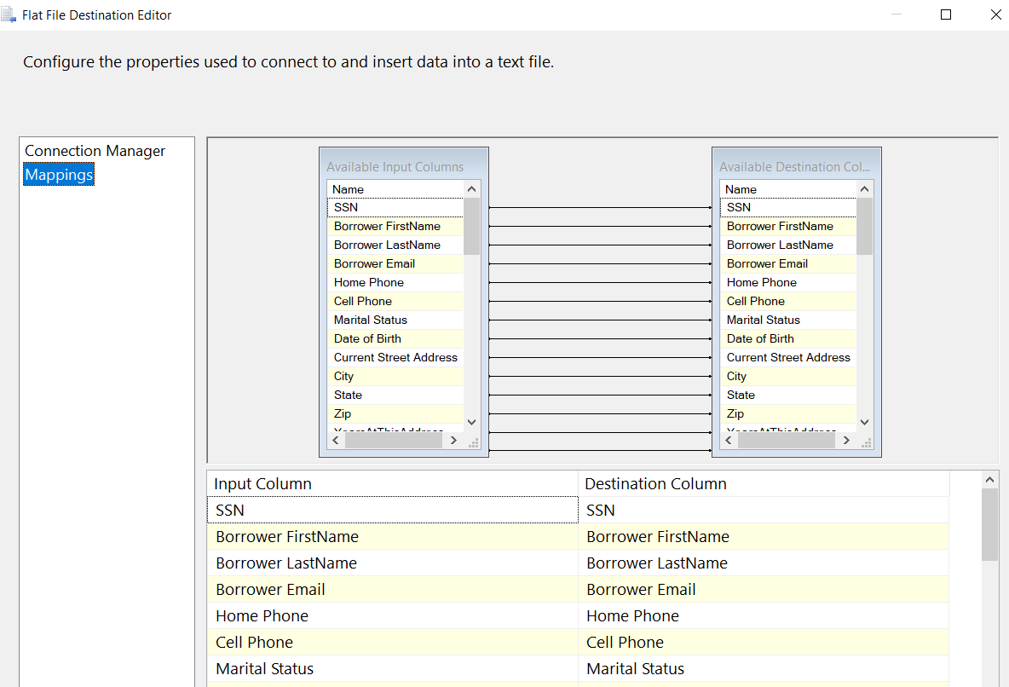

This is Flat file connection editor for selecting different rows to create in new flat file.

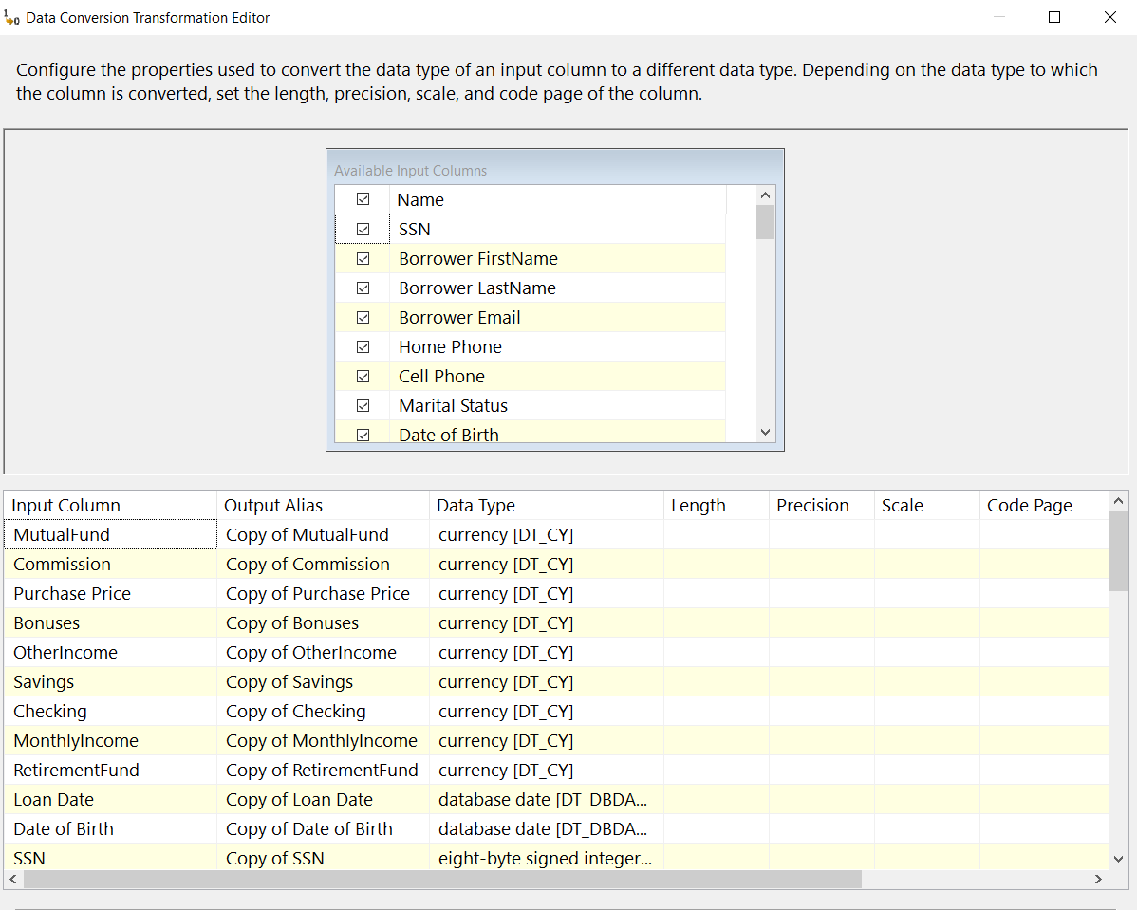

This is data conversion transformation editor convert rows to different data types to load to ODS

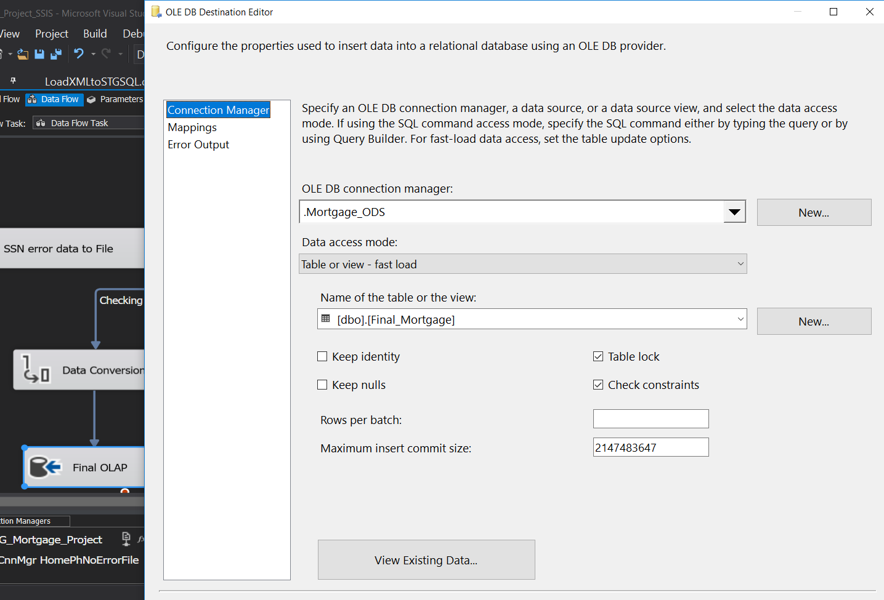

This is OLED be destination editor where we select Connection Manager and final table Mortgage table to load all data into.

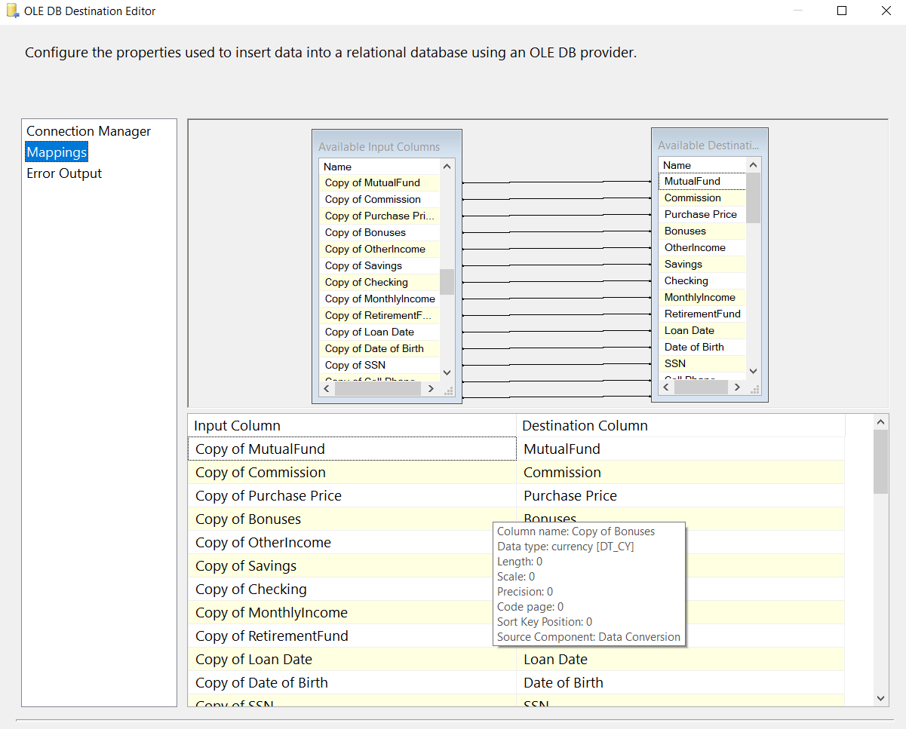

This image shows the mapping of upstream columns to oledb destination which is ODS for different columns.

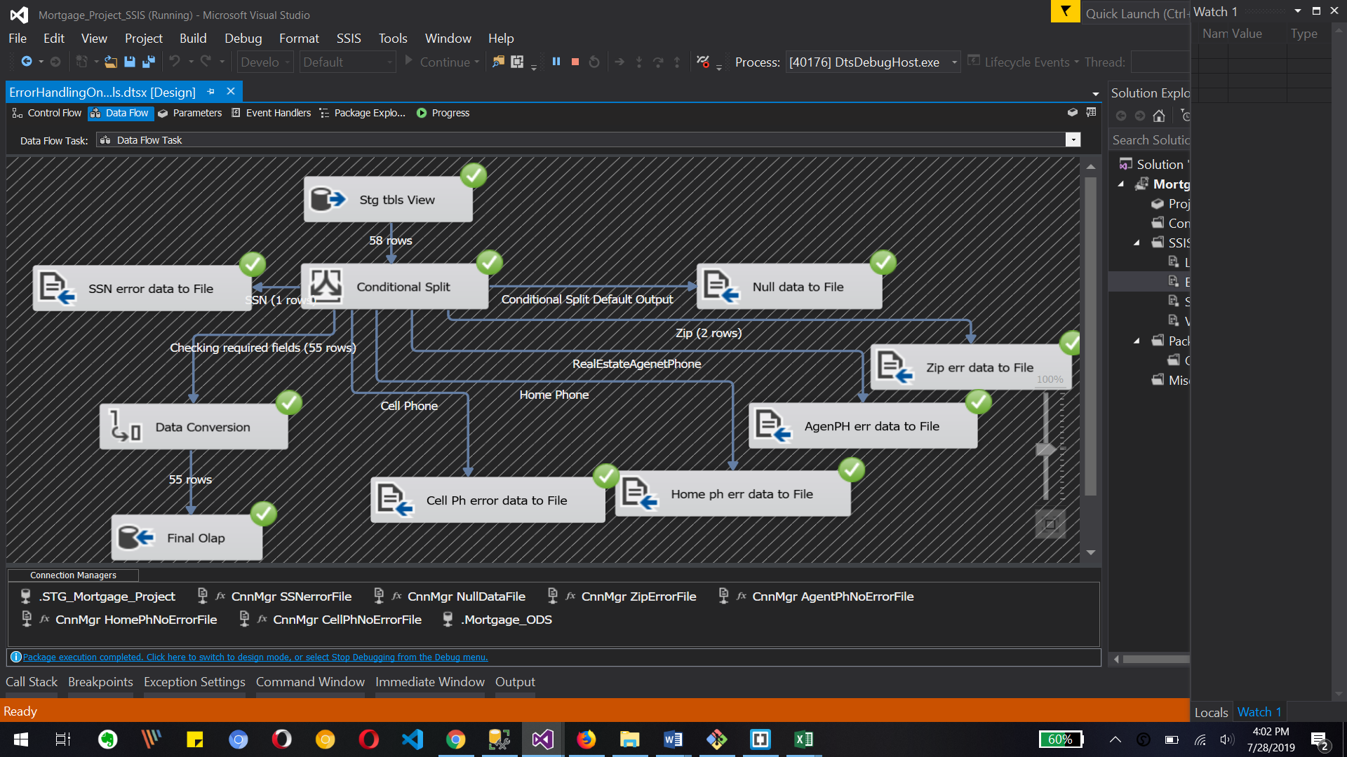

The image shows the execution of our package which is successful. we have total 3 Row in error files and 55 rows in final table out of total 58 rows as an input.

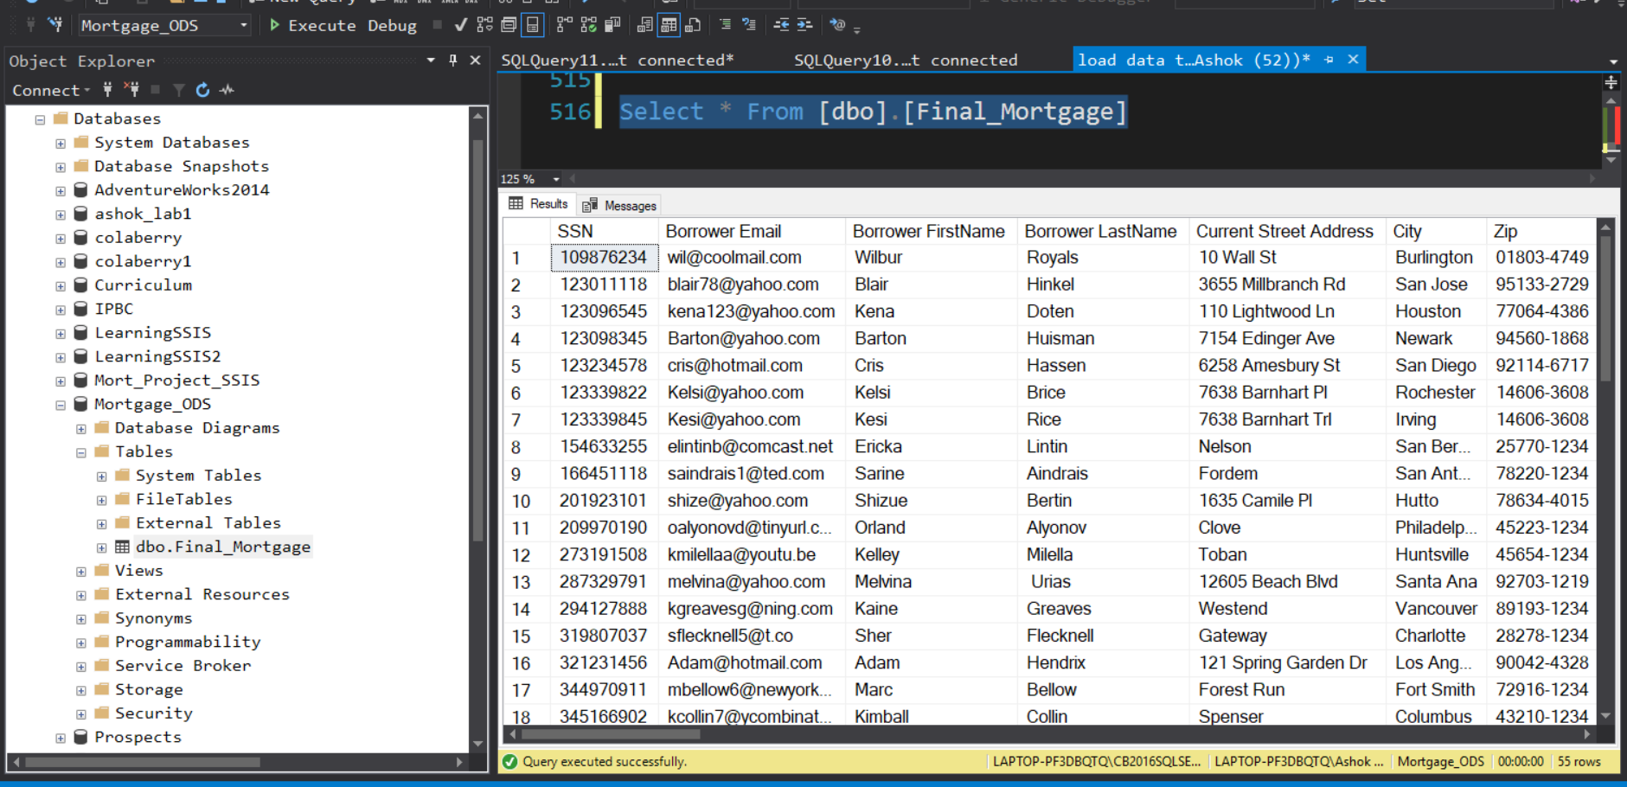

This is the final output of our final_mortgage table in ssms which shows 55 rows successfully added to this table with the help of ssis package

Video(s) to Submit:

What to Submit:

1. Copy and paste the link to your video(s) as part of your homework.
2. SQL BI Interview Questions: SSIS – Describe a complex Package built in the past you are proud of

<https://app.colaberry.com/app/ipbc/videos?user=31221&category=136>

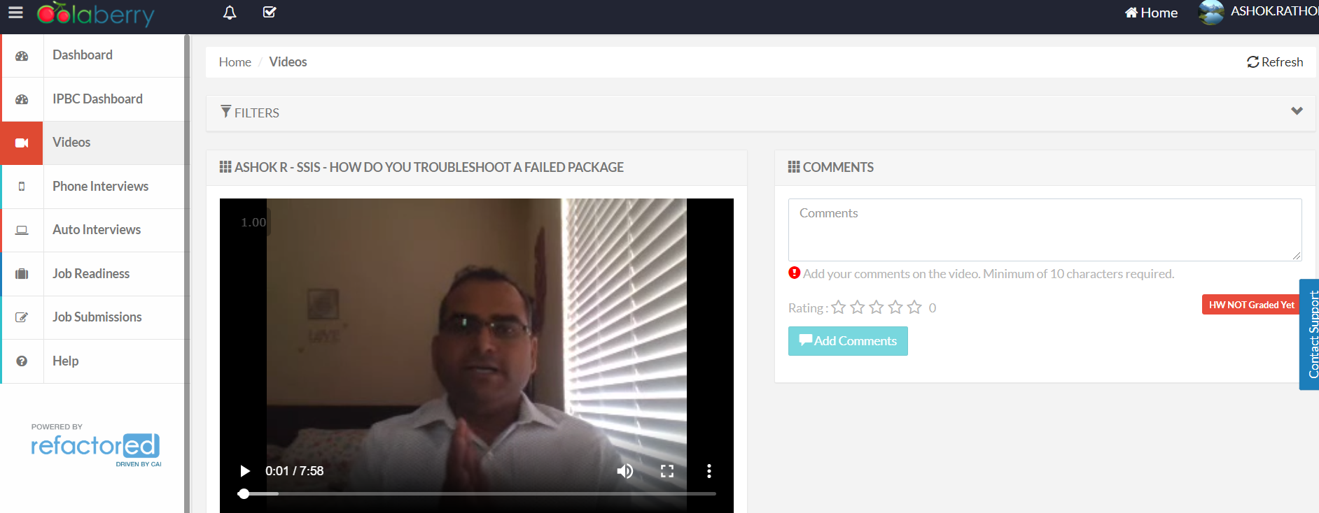

1. SQL BI Interview Questions: SSIS – How do you troubleshoot a failed Package

<https://app.colaberry.com/app/ipbc/videos?user=31221&category=38>

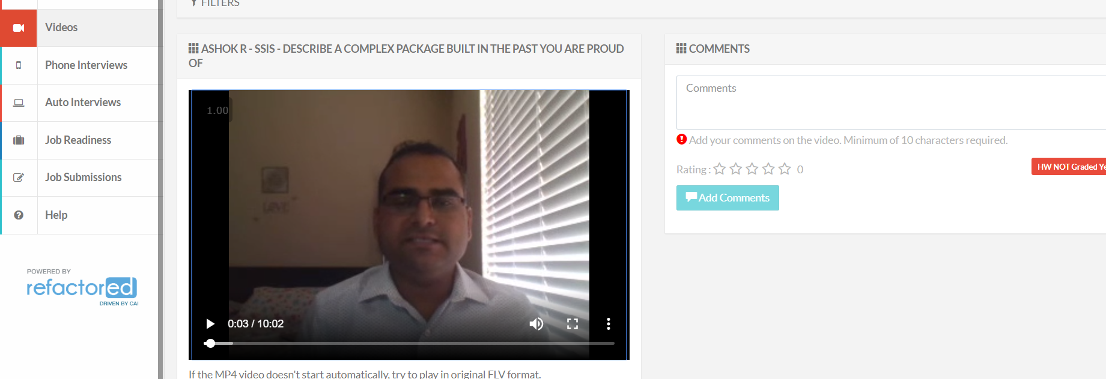

1. Watch, Comment &amp; take screenshots of your comments from 3 other videos on the same topic (per question). Comments must be 20+ characters. Leave comments based on presentation, delivery and/or technical details. Your critiques will help you be more conscious of your own videos. (3 comment screenshots per Video Question)
   1. SSIS – Describe a complex Package built in the past you are proud of

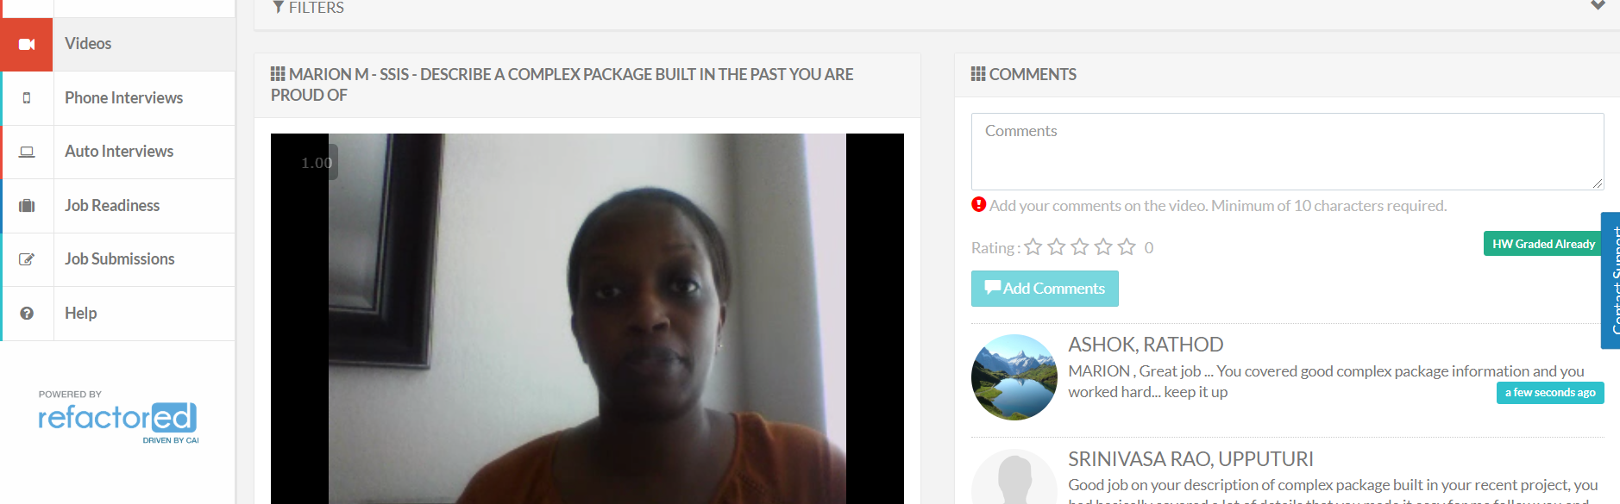

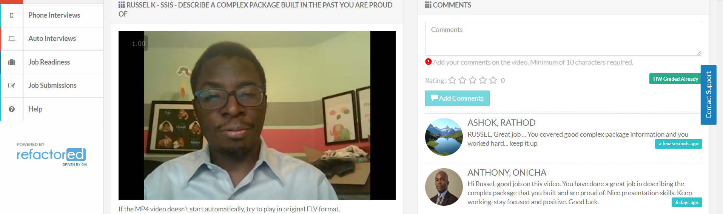

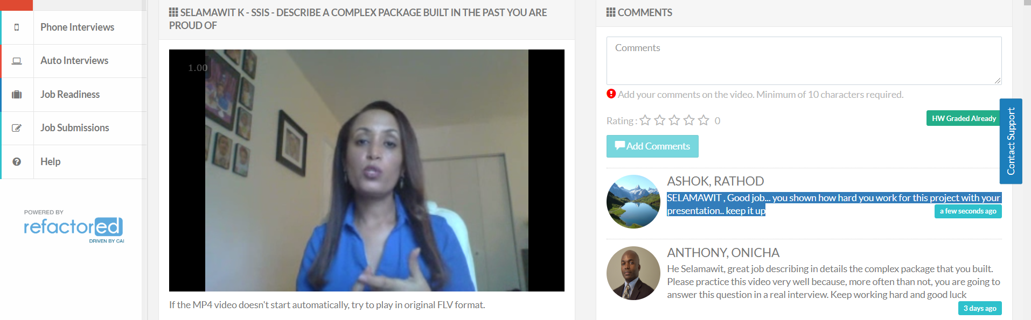

* 1. SSIS – How do you troubleshoot a failed Package

